About Hacking Club
Hacking Club is a platform to learn cybersecurity, an incredible resource if you don’t know where to start. In addition to vulnerable machines, you have access to classes and challenges to practice your skills and access to an exclusive community to play and challenge yourself.

The best part about Hacking Club is that it is very hands-on. If you are new to hacking, give it a try.

Introduction
This write-up refers to the Worknet ENG machine. If you require support, please open a ticket in the support channel on the Discord server.

Nmap Scan:
We need to know which services are running in the background and which ports are open. So, we will use a tool called nmap.
Ports:
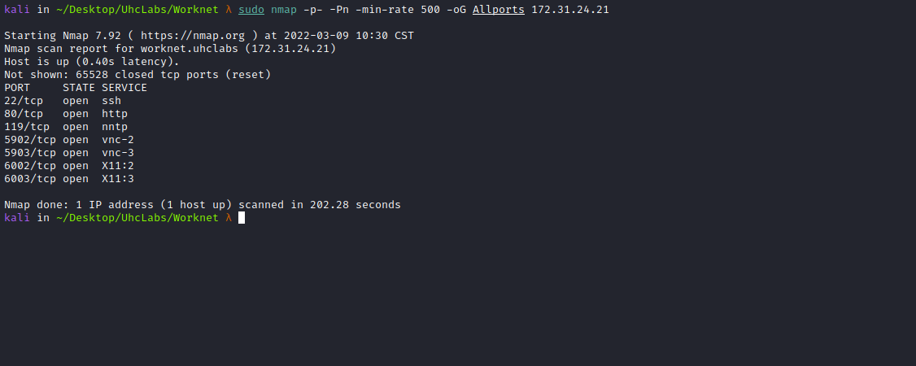


In the footer of the website, we can download our VPN client.
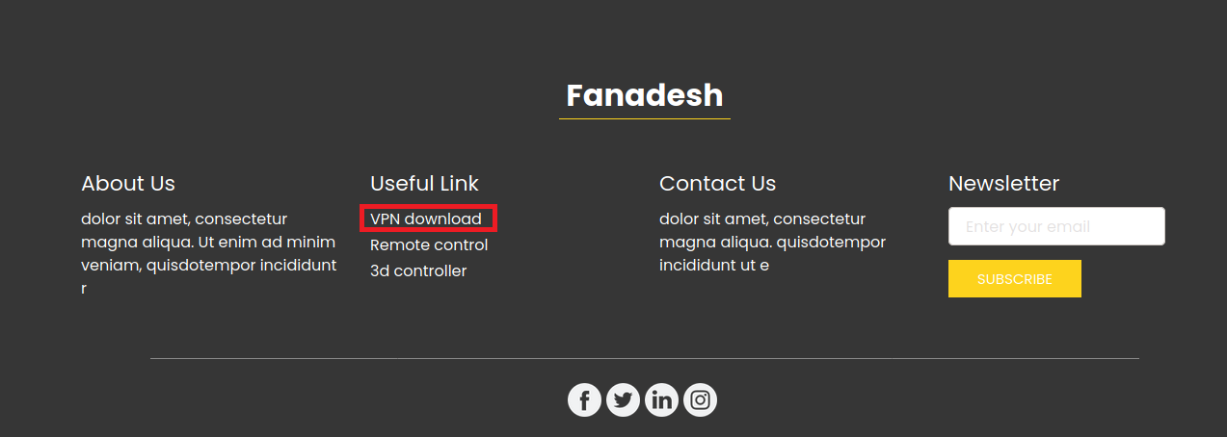
After downloading it, we can start the VPN.
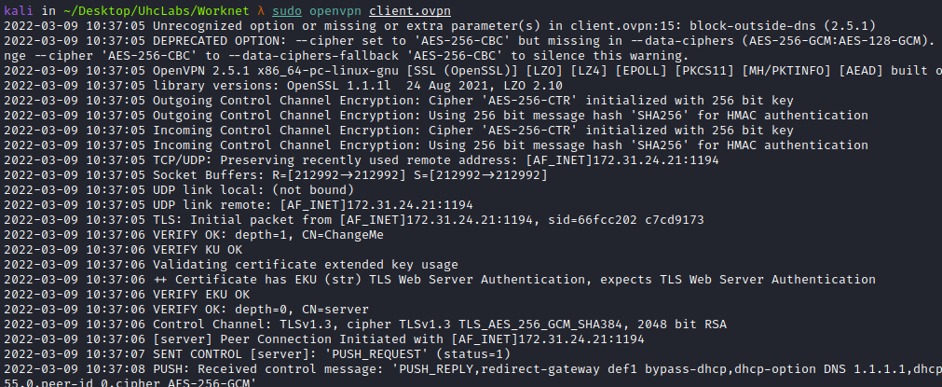
We can then scan the network 10.96.0.0:
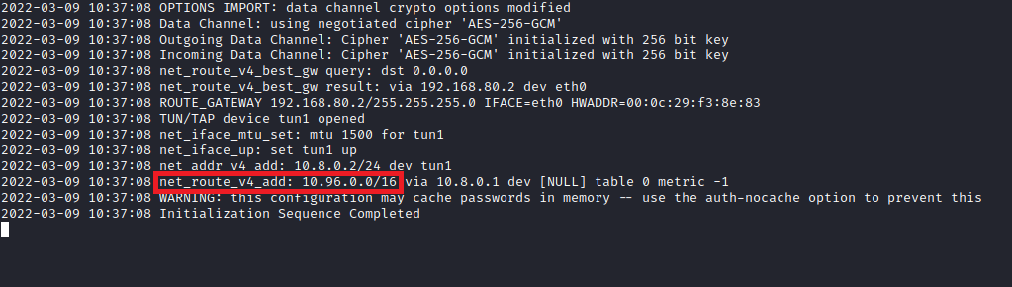

sudo nmap -sn 10.96.0.0/24
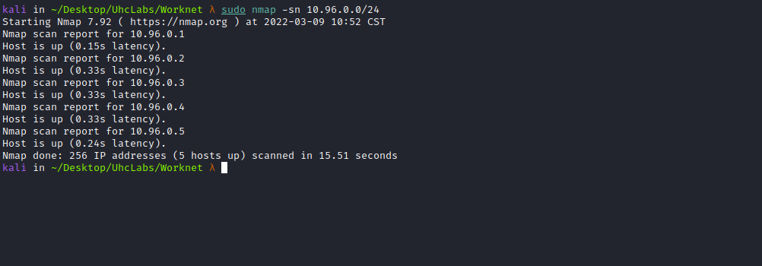

We have 5 hosts:
- 10.96.0.1
- 10.96.0.2
- 10.96.0.3
- 10.96.0.4
- 10.96.0.5
We will perform a port scan on these hosts. To automate it, I created a script =)
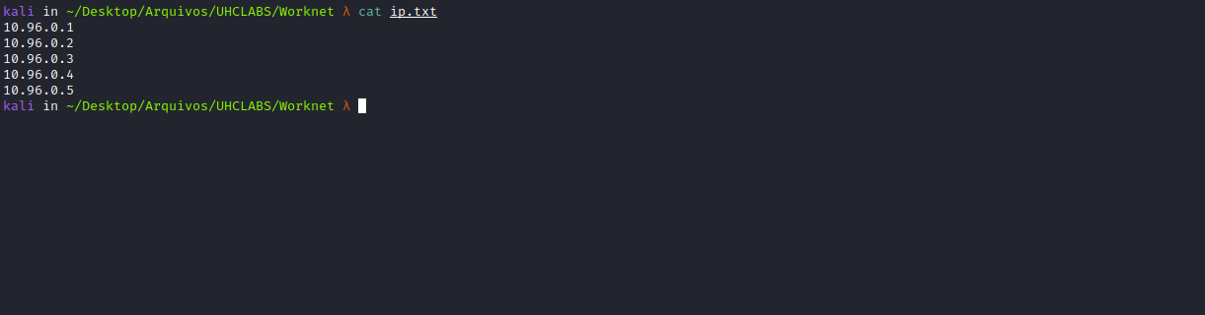
for i in $(cat ip.txt); do sudo nmap --min-rate 500 --open -p- -Pn $i; done
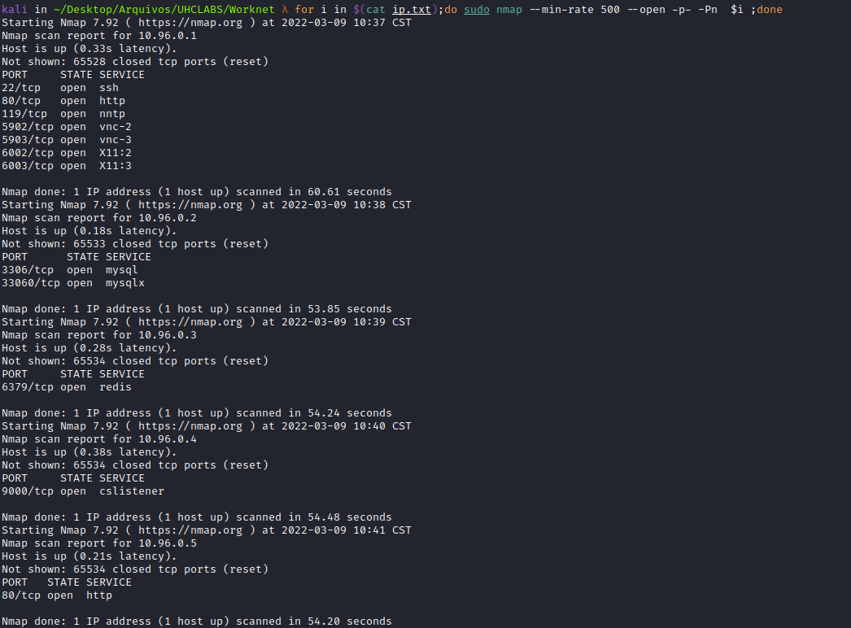
On host 10.96.0.3, we find Redis, so we can access it using the tool → redis-cli.
Redis is a non-relational database that stores data in memory.

6379 – Pentesting Redis
By default, Redis can be accessed without credentials. However, it can be configured to support only a password, or username + password. It is possible to set a password in the configuration file using the requirepass parameter or temporarily until the service restarts by running:
https://book.hacktricks.xyz/pentesting/6379-pentesting-redis
redis-cli -h 10.96.0.3
keys *
get PHPREDIS_SESSION:f49cbcc738dfa26217d911d3d8e407bb
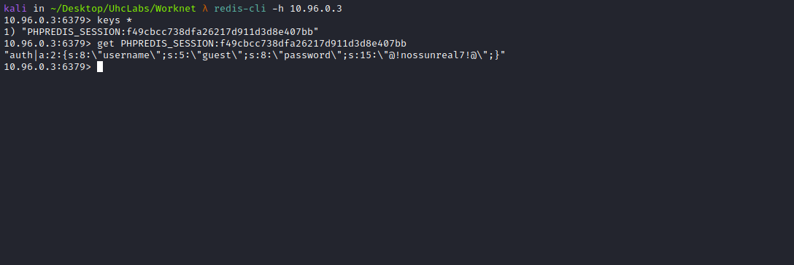
Now we have a session stored in Redis. By accessing host 10.96.0.5, we can use this credential to log in.
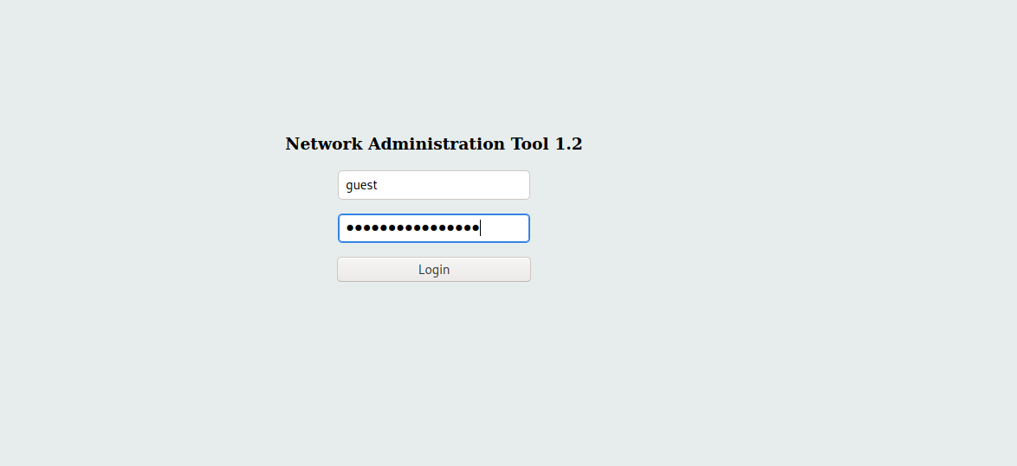
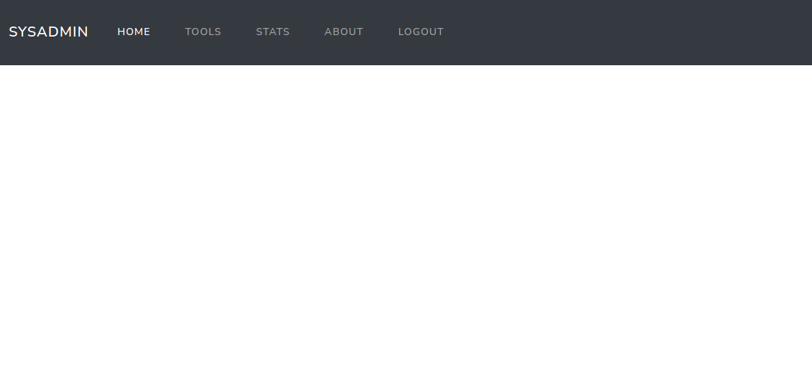
The problem here is that we cannot do anything because we do not have permission to access features such as tools, stats, etc.
To do that, we need to be admin.
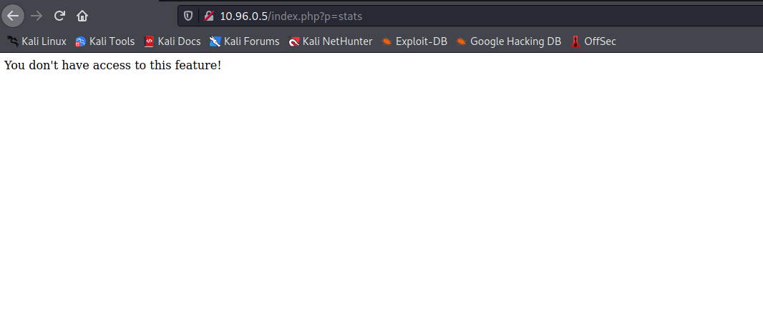
But we can try a Path Traversal hehe, and after attempting it, we get the following error.
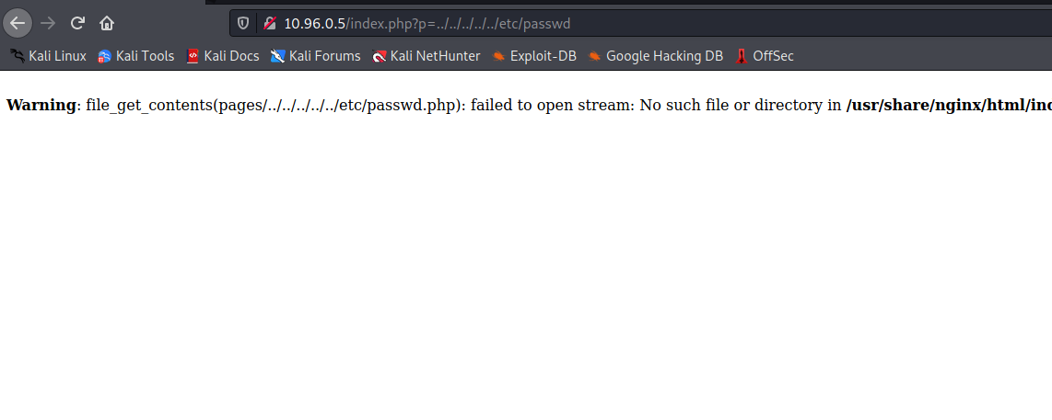
After attempting a bypass, I think about something we could read that is not inside pages, so I will perform file fuzzing. This way, we can try reading something by going back one directory.
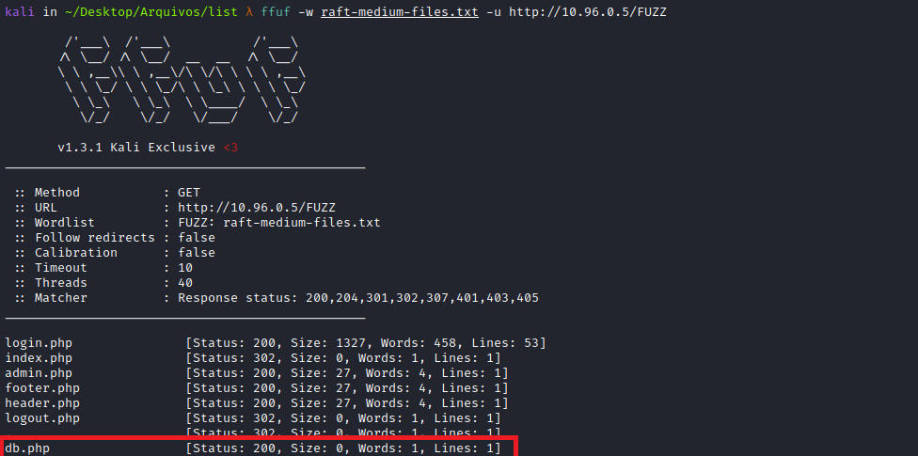
The file db.php looks interesting hehe, so we can read it:
http://10.96.0.5/index.php?p=../db
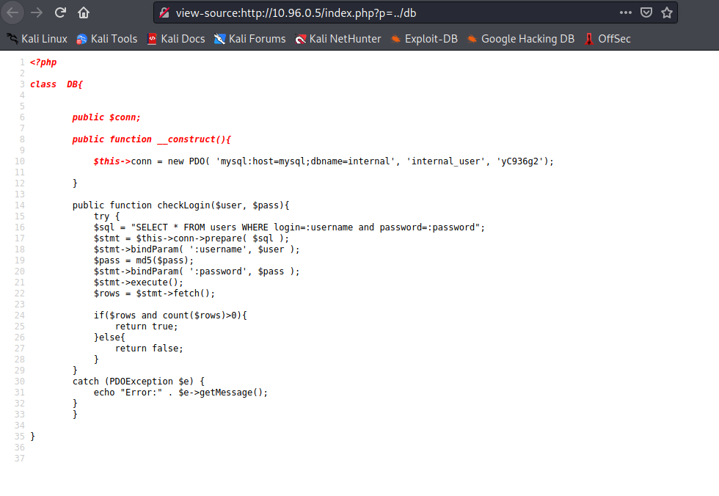
Reading this file, we can find the database credentials =)
internal_user:yC936g2
We can access host 10.96.0.2 and log in to the database.
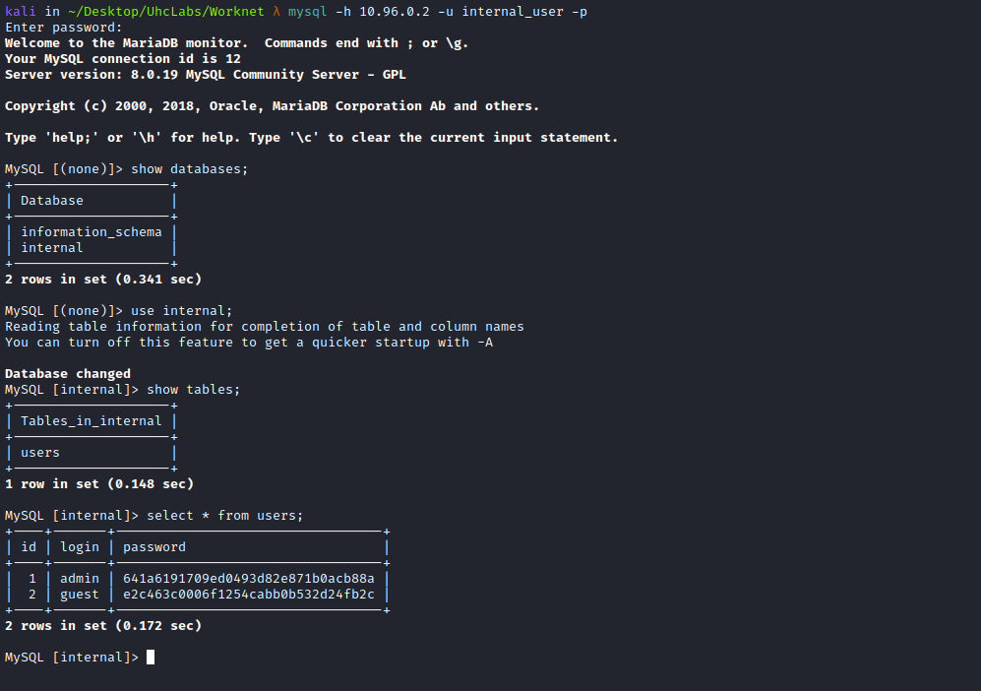
After accessing the database, we see the database internal, so we access the table users.
After querying the table, we obtain the admin login and password. However, the password is in MD5, so we will use the website below to crack the hash:
CrackStation - Online Password Hash Cracking
https://crackstation.net/
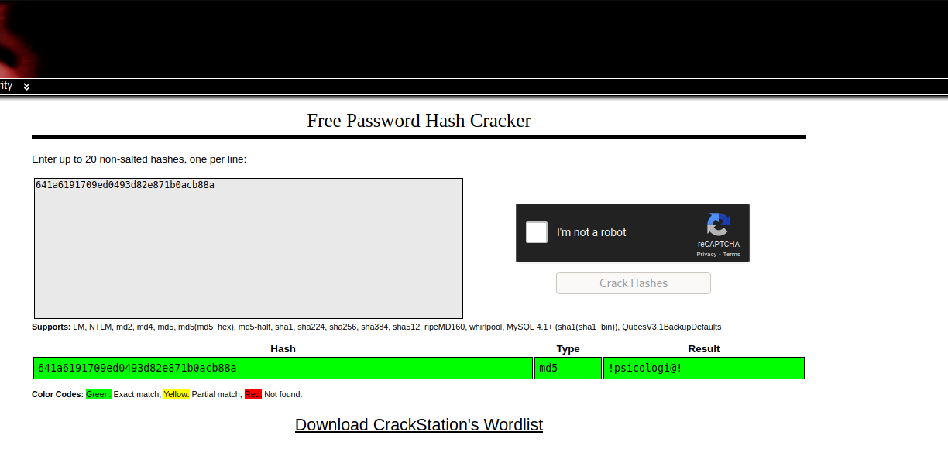
Now we have the password to log in as admin.
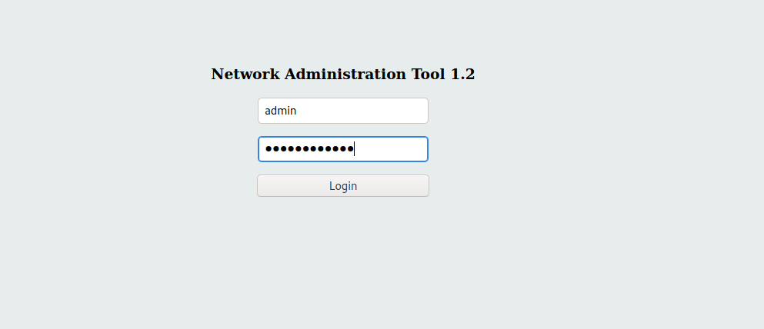
After logging in, we can access stats, and from there retrieve our first flag.
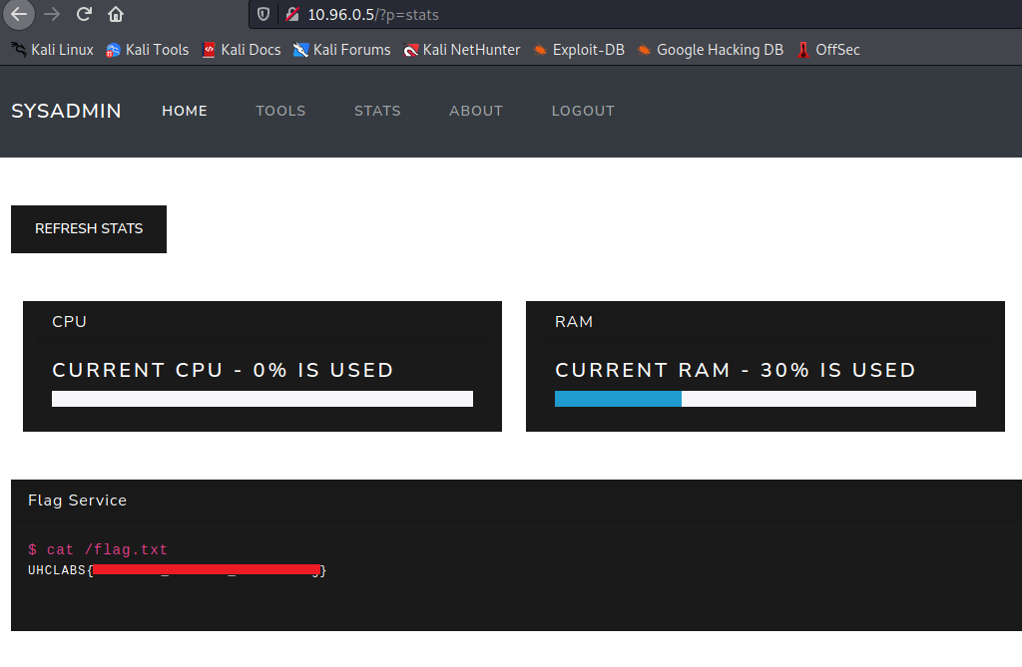
Looking at the source code of the stats page, we find something interesting → /?p=stats&s=netstat.
It is passing the netstat command and returning its output.
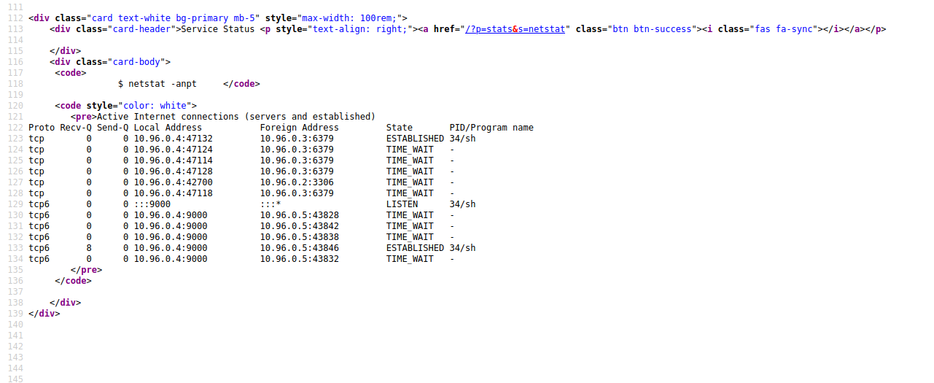

Command Injection
We can intercept this request using Burp Suite for better analysis =)
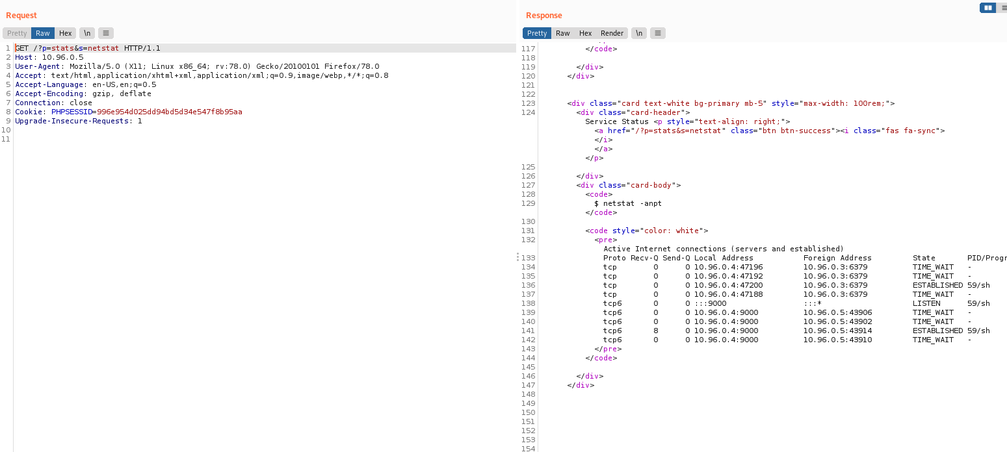
We can replace the netstat command with ls.
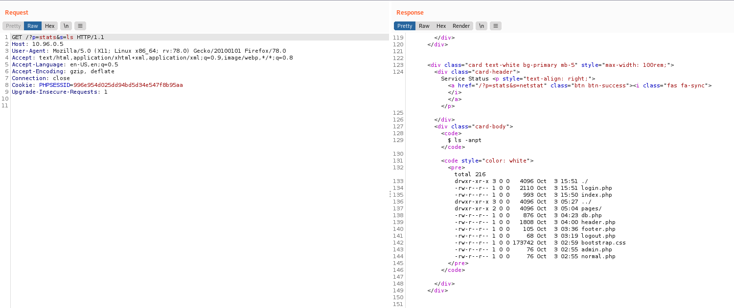
And we get command injection =)
After listing some directories, I discover a backdoor in /tmp named sh. Inside this file, we find a reverse shell already configured with our VPN IP hehe.
However, to read this file we must use the more command, because cat, strings, etc., do not work.
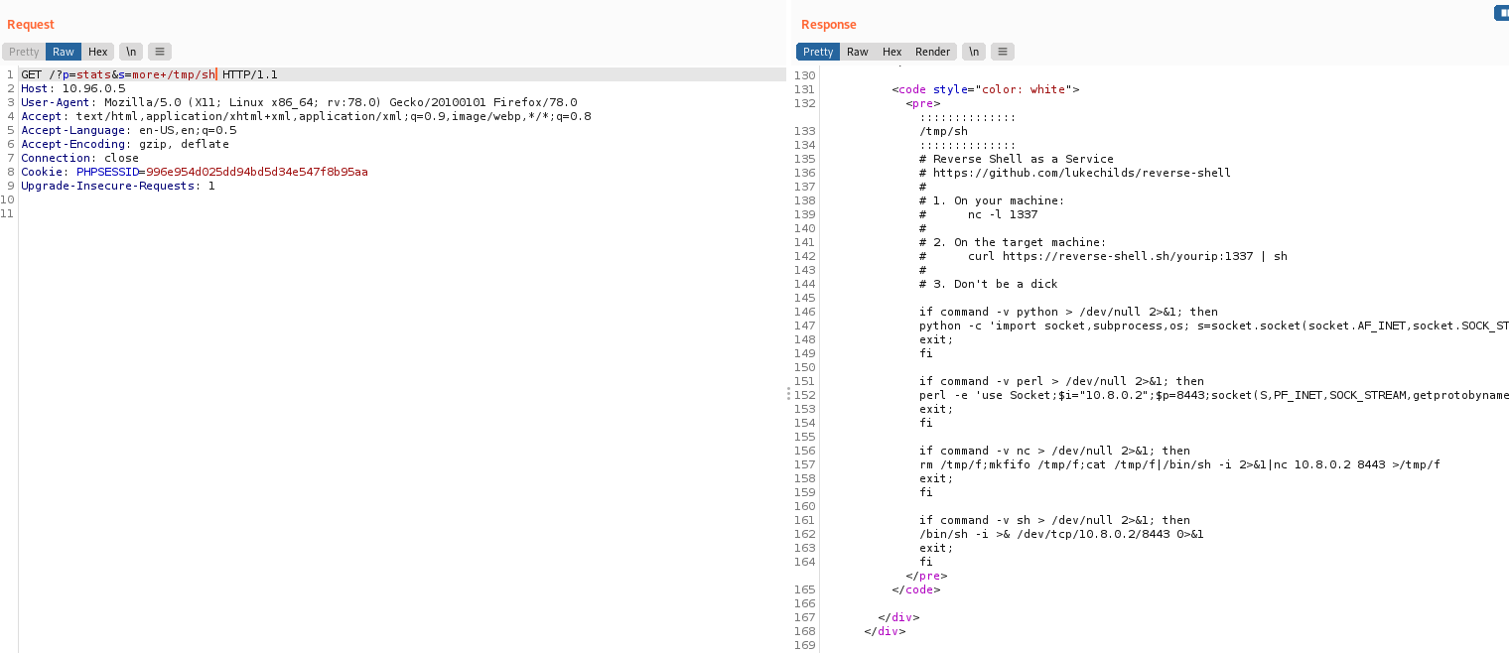
Netcat listener to receive the connection:
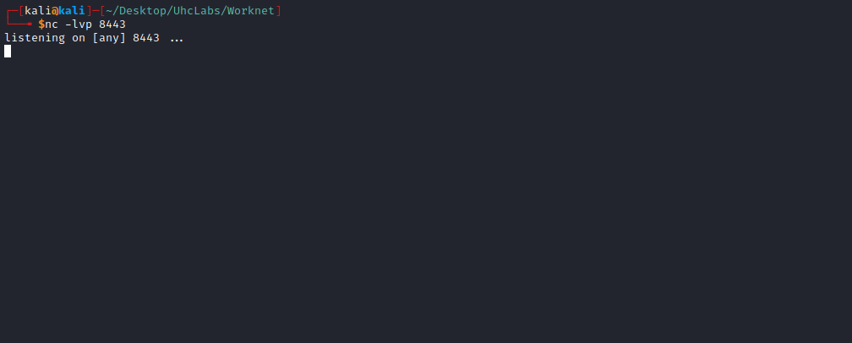

sh /tmp/sh
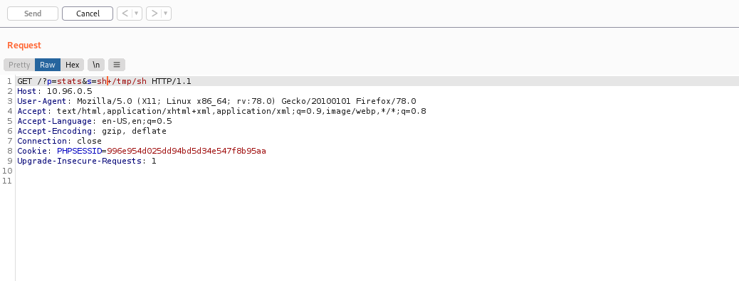
And we get a shell =)
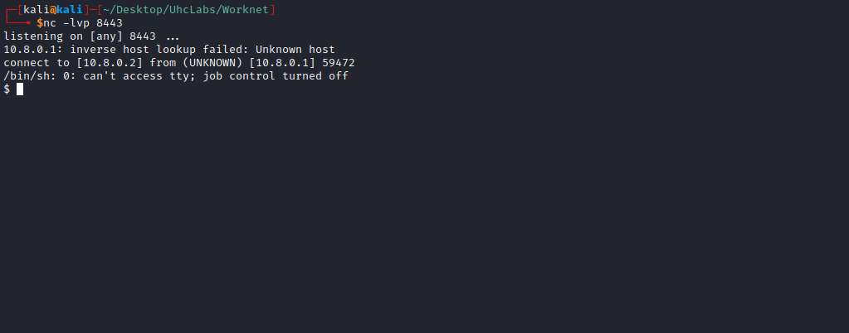

Shell TTY without Python
Upgrading a simple shell to a fully interactive TTY:
script /dev/null -c bash
Ctrl+Z
stty raw -echo; fg
Enter
export TERM=xterm

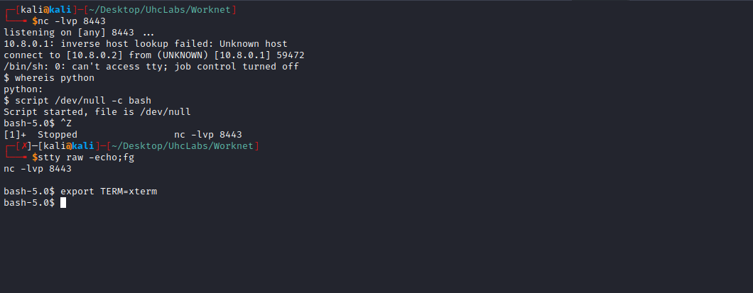

Privesc
After obtaining a fully functional shell, I begin basic enumeration.
find / -perm /4000 2>/dev/null
I start by searching for SUID binaries.
After running the command above, I find the bash binary =)
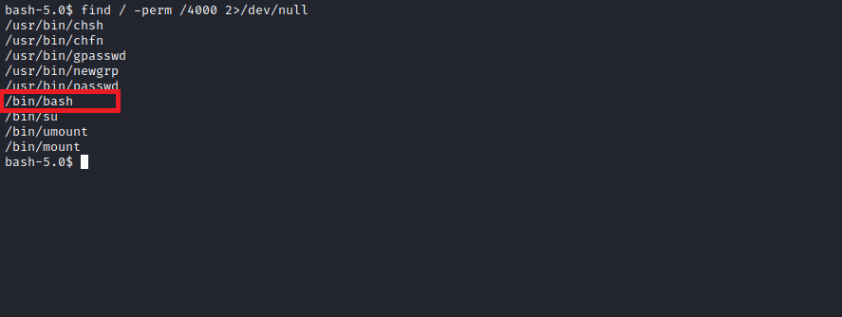
This runs the bash binary with the owner’s privileges — in this case, the root user.

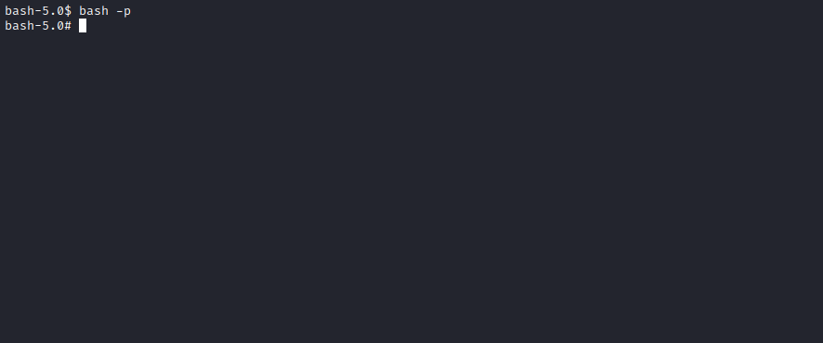
Going into the root directory to see if we can find the final flag.
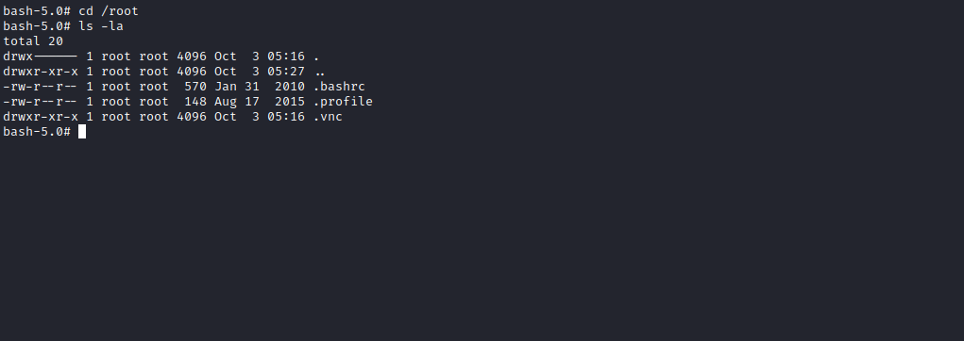
There is no flag there, but there is a hidden directory → .vnc.
Accessing this directory, we find a password inside the file passwd.
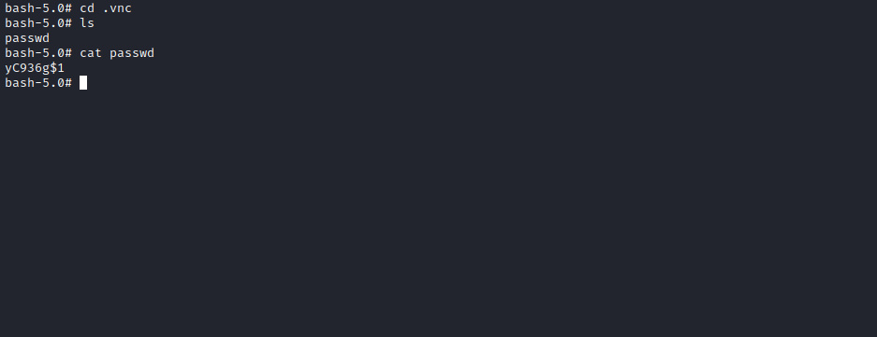

VNC
VNC (Virtual Network Computing) is an internet protocol that allows remote viewing of graphical interfaces through a secure connection. In simple terms, you can view and access the entire content of another computer remotely over the internet.
We can use this password to connect via VNC using vncviewer to access host 10.96.0.1:
vncviewer 10.96.0.1:5903
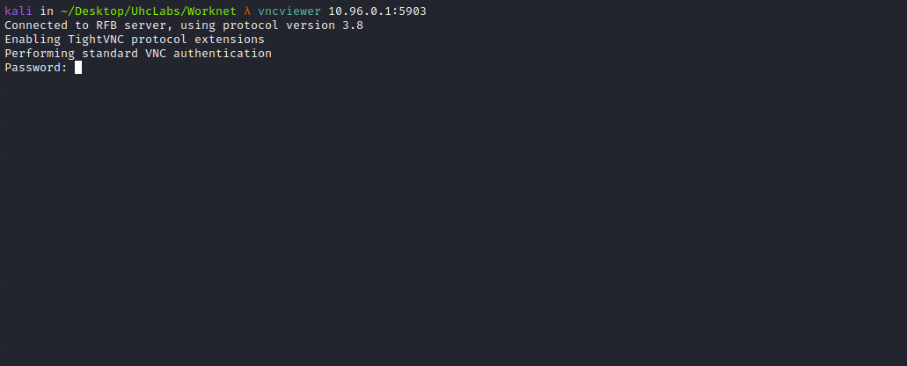
After accessing VNC, we receive a message.
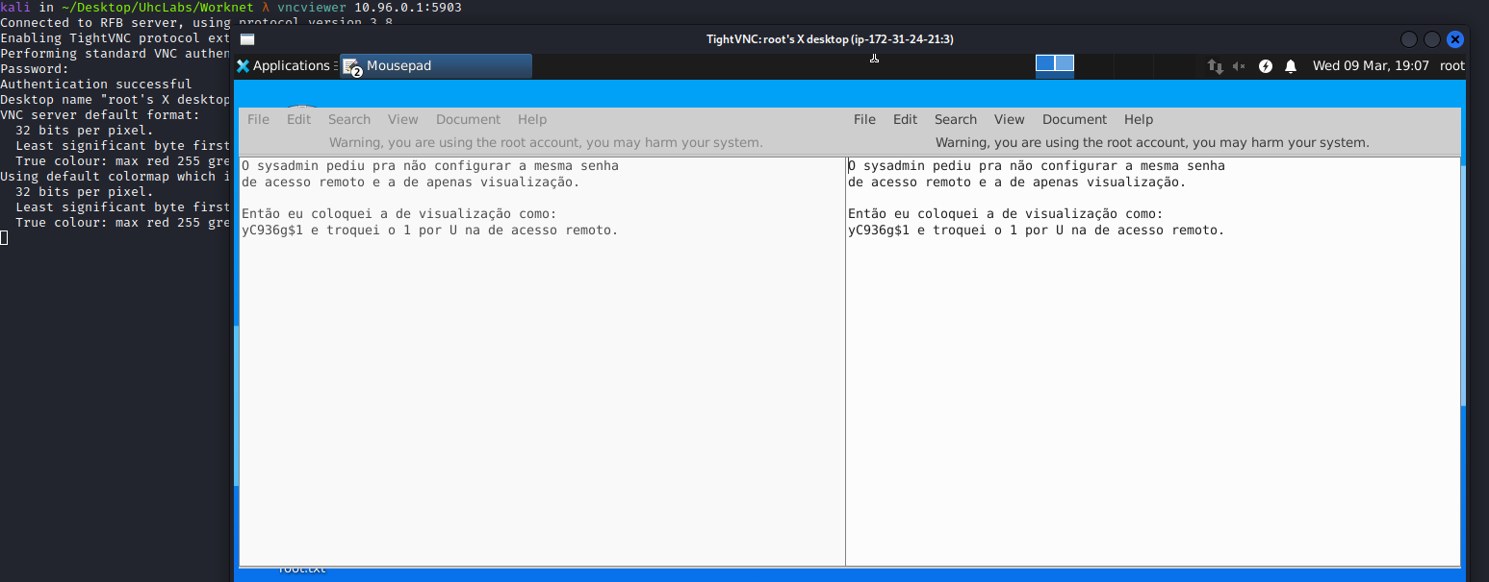
So we replace the 1 with U and log in again.
After logging in, we can navigate the system.
Accessing the Desktop directory, we find the file root.txt.
Reading this file, we retrieve our final flag =)
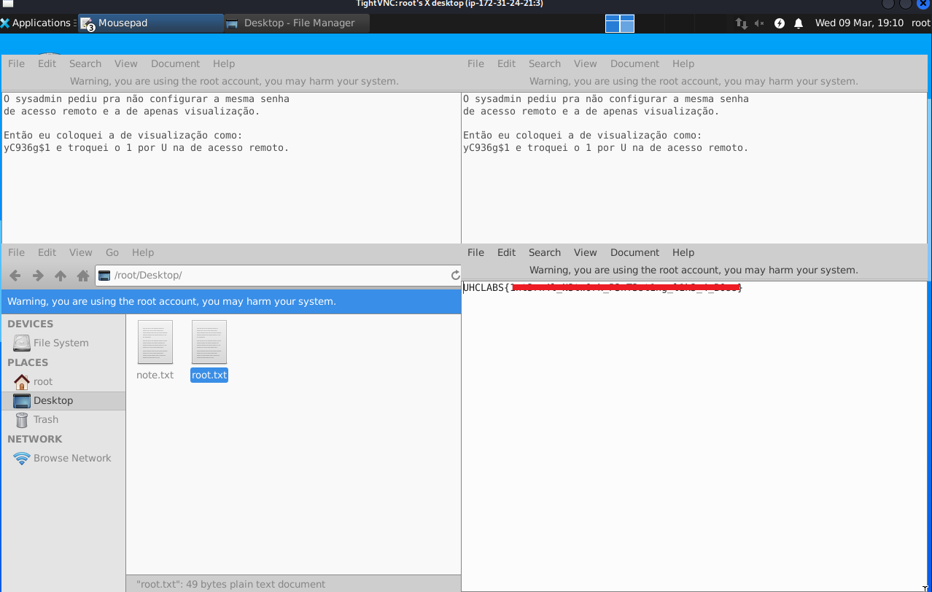
However, we have a small problem: we cannot copy the flag directly, meaning we would have to type it manually. Instead, we can use Netcat to send the file to our machine.
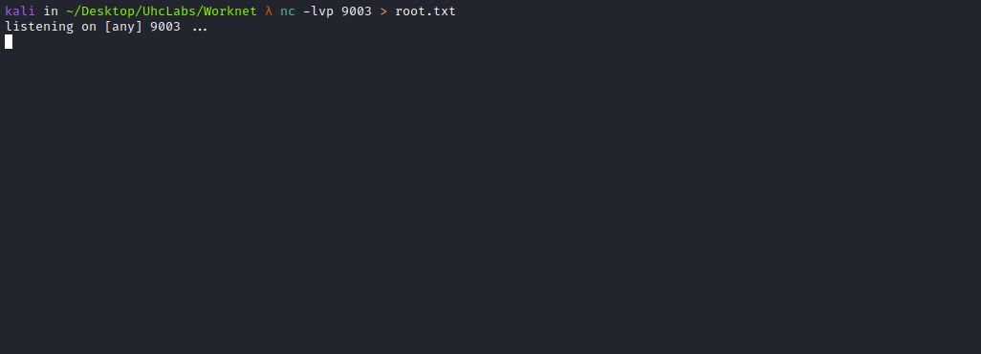
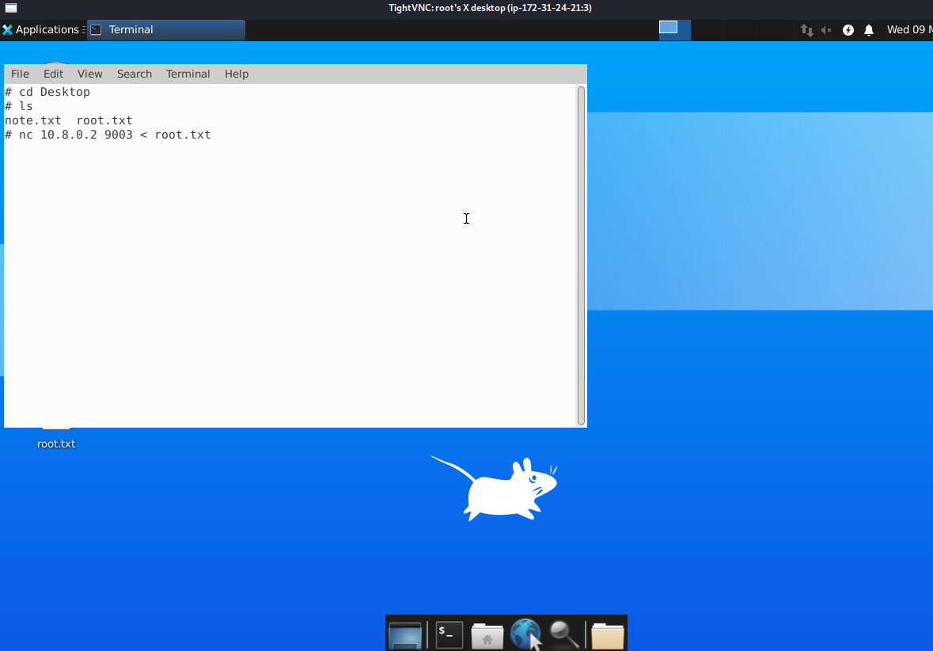
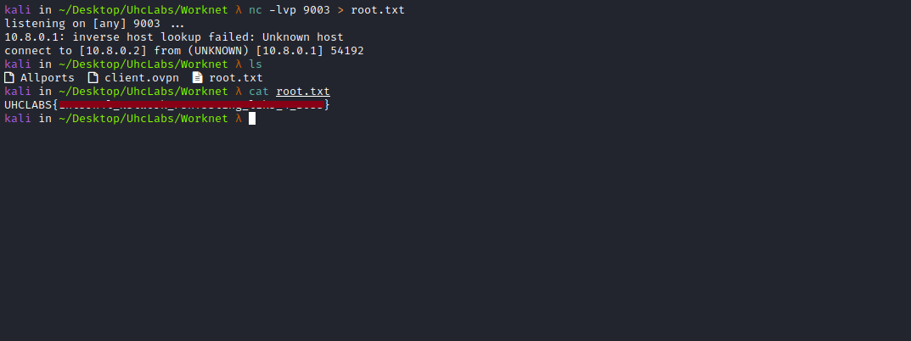
Now we have the file locally and can read the final flag.

